COMMUNITY QUILT DAYS 2023-24
Saturdays booked are:
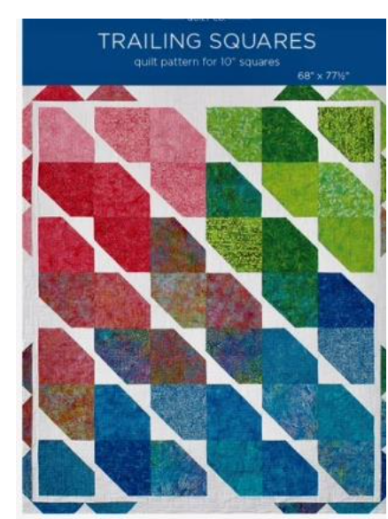
October 21

We will be hosting the first community quilt day and will be using the Trailing Squares pattern from Missouri Star Quilts, see link below for a very good YouTube video on it. https://youtu.be/9Gudk0qNg4Q?si=Ctp6w1X8GxMYDXna
Hope to see you then,
Chantal Fleury-Wahamaa Gisele McVittie
******************************************************************
November 18
January 20
February 24
March 23

